

*State space modeling and analysis*

Lab Experiment 01

SUBMITTED BY

**MAHMOOD HASSAN (117035990004)**

2018

Submitted By;

Mahmood ul Hassan

(117035990004)

Lab experiment 1  
State space modeling and analysis

Objectives1) Learn how to set up a transfer function, or a state space model of a system, and the  
transformation between them using MATLAB.

2) Learn how to find the solution to the state space model using MATLAB.  
3) Learn how to add different inputs to a system and observe the outputs of the system.

# Question 01

For a discrete system：

***y***(***k*** + 2) + 4 ***y***(***k*** +1) + 5***y***(***k***) = ***u***(***K*** + 2) + 2***u***(***k*** +1) + ***u***(***k***)

Find the transfer function of the system using function tf(), set up the state space model, poles and zeros.

# Solution of Question 01

# Calculations

For finding the transfer function we should rewrite the equation in output/input form  
and in terms of discrete time variable ‘z’.

$$z^{2}y+4zy+5y=z^{2}u+2zu+u$$

$$\left(z^{2}+4z+5\right)y=\left(z^{2}+2z+1\right)u$$

$$\frac{y}{u}= \frac{\left(z^{2}+2z+1\right)}{\left(z^{2}+4z+5\right)}$$

$$Tansfer Function= \frac{\left(z^{2}+2z+1\right)}{\left(z^{2}+4z+5\right)} …………… eq(1)$$

To set up the state space model we convert the transfer function eq (1) in proper Rational function.

$$\frac{\left(z^{2}+2z+1\right)}{\left(z^{2}+4z+5\right)}=1+\frac{-2z-4}{\left(z^{2}+4z+5\right)}$$

Controllable canonical form Realization is

$$A=\left[\begin{matrix}0 & 1 \\ -5 & -4\end{matrix}\right], B=\left[\begin{matrix}0 \\ 1\end{matrix}\right], C=\left[\begin{matrix}-4 & -2\end{matrix}\right], D=1$$

# Matlab Steps

1. In Matlab for finding the transfer function we define numerator and denominator of above equation eq(1) and set the sample time (Ts) for discrete time transfer function by using the command **tf (numerator, denominator, Ts).**
2. To find the state space model from computed transfer function we will use  
   **tf2ss(numerator, denominator)** command which will give us the matrix A, B, C, D.
3. To find the poles and zeroes from computed transfer function we will use the command **[poles,zeros]= pzmap(TranFun).**

# Matlab Result

Matlab Result of Transfer Function is given below.

# 

Matlab Result of state space model is given below.

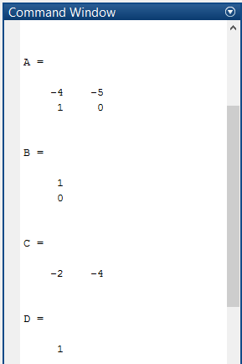

Matlab Result of Poles and zeroes is given below.

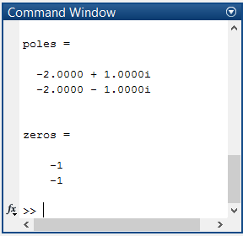

Matlab plot of Poles and zeroes is given below.

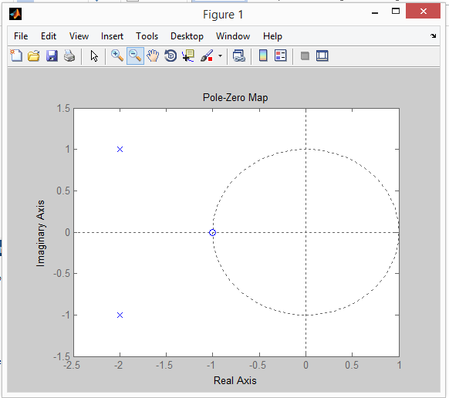

# Matlab Code

%Question No 1

clear all

close all

clc

% Finding Transfer Function

num = [1 2 1];

den = [1 4 5];

TranFun = tf(num ,den, -1)

% Finding State space model

[A,B,C,D]= tf2ss(num, den)

%Finding poles and zeros

[poles,zeros]= pzmap(TranFun)

figure;

pzmap(TranFun)

# Question 02

For the following MIMO system, find the transfer function matrix using function tf(), set up a state space model, find the poles and zeros of the system.



# Solution of Question 02

# Matlab Steps

1. In Matlab for finding the transfer function of MIMO system we use two different methods.
   1. Method (01)

For given MIMO system we define numerator and denominator of each element of given matrix by using the command **“tf (numerator, denominator)”,** after this compile all the entries in single matrix form.

* 1. Method (02)

We create a matrix “MIMO_num” contains all numerator of MIMO matrix and also create another matrix “MIMO_den” contains all denominator of MIMO matrix, then find the transfer function using command **“tf(MIMO_num, MIMO_den)”**.

1. In Matlab for finding the state space model of MIMO system we use two different methods.
   1. we use **“ss(Transfer fun)”** command which will give us state space parameters
   2. we use **“ssdata(ss(Transfer fun,’min’))**” command which will give us state space parameters.
2. To find the poles and zeroes from computed transfer function we will use the comand **[poles,zeros]= pzmap(TranFun).**

# Matlab Result

Matlab Result of Transfer Function of Method 01 is given below.

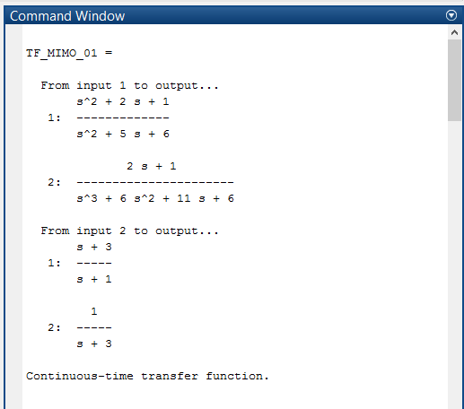

Matlab Result of Transfer Function of Method 02 is given below.

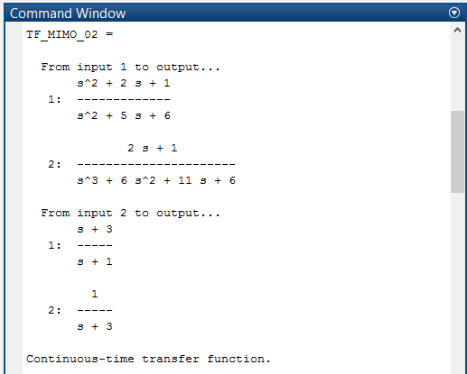

Matlab Result of state space model using Method 01 is given below.

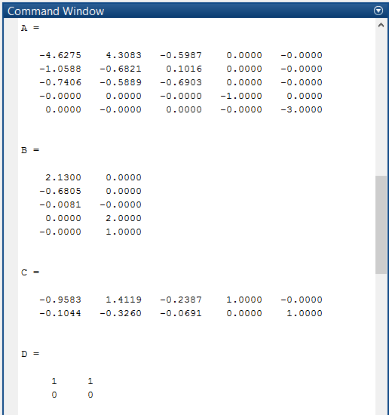

Matlab Result of state space model using Method 02 is given below.

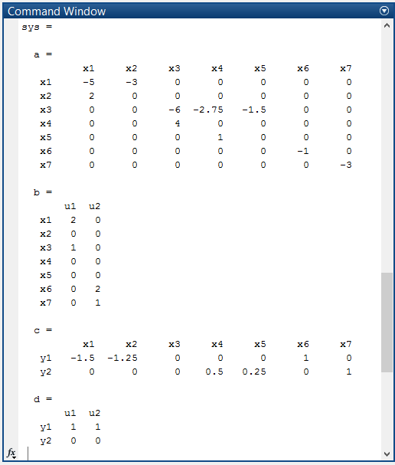

Matlab Result of Poles and zeroes is given below.

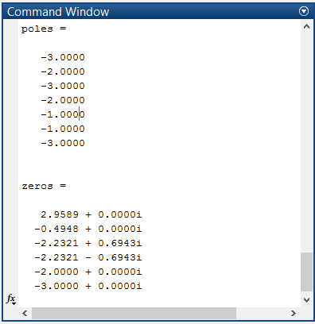

Matlab plot of Poles and zeroes is given below.

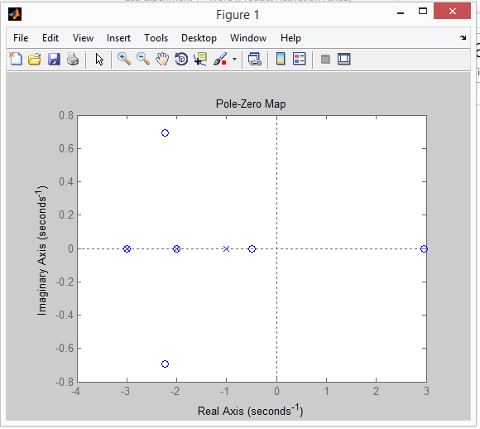

# Matlab Code

%Question No 2

clear all;

close all;

clc;

% Method 01 for finding Transfer function

TF11=tf([1 2 1],[1 5 6]);

TF12=tf([0 1 3],[0 1 1]);

TF21=tf([0 2 1],[1 6 11 6]);

TF22=tf([0 0 1],[0 1 3]);

TF_MIMO_01=[TF11,TF12;TF21,TF22]

% Method 02 for finding Transfer function

MIMO_num = {[1 2 1 ] [0 1 3]; [0 2 1] [0 0 1]};

MIMO_den = {[1 5 6 ] [0 1 1]; [1 6 11 6] [0 1 3]};

TF_MIMO_02=tf(MIMO_num,MIMO_den)

% Method 01 for finding State space model

[A,B,C,D]=ssdata(ss(TF_MIMO_02,'min'))

% Method 01 for finding State space model

sys = ss(TF_MIMO_02)

%Finding poles and zeros

figure

[poles,zeros]= pzmap(sys)

pzmap(TF_MIMO_02)

figure

pzmap(TF_MIMO_01)

# Question 03

For the following state space mode, find the transfer function of the system



# Solution of Question 03

# Matlab Steps

In Matlab for finding the transfer function of given system we use two different methods.

1. From the given state space model we define the matrix A, B, C and D, then we find state space model using matlab command **“sys = ss(A, B, C, D)”**, after that we find transfer function using command **“tf(sys)”.**
2. From the given state space model we define the matrix A, B, C and D, Then by using **“ss2tf (A,B,C,D)”** command which get us numerator and denominator of the transfer function. Then to represent the numerator and denominator in terms of transfer function we use **“tf (numerator, denominator)”** command.

# Matlab Result

Matlab Result of Transfer Function is given below.

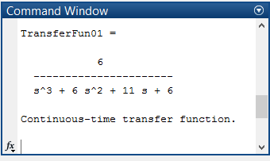

# Matlab Code

%Question No 3

%For the given state space mode, find the transfer function of the system4

close all;

clear all;

clc;

A = [0 1 0; 0 0 1; -6 -11 -6];

B = [0 0 6]';

C=[1 0 0];

D=0;

% Method 01 for finding Transfer function

sys = ss(A, B, C, D)

TransferFun01 = tf(sys)

% Method 02 for finding Transfer function

[num,den] = ss2tf (A,B,C,D);

TransferFun02 = tf(num,den)

# Question 04

Find the eigenvalues of the following system and the corresponding transformation  
matrix.



# Solution of Question 04

# Matlab Steps

1. From the given state space model we define the matrix A, B, C and D, in matlab then we find Eigenvalues and matrix of Eigenvector using matlab command **“[EigenVector, EigenVal_Digonal]=eig(A)”**
2. Eigen values computed by using state space matrix are same as poles of system. We can also find Eigen Values by using command **“pzmap(sys)”.**

# Matlab Result

Matlab Result of eigenvalues is given below.

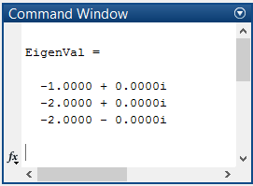

Matlab Result of eigenvalues which are diagonal element of given matrix is given below.

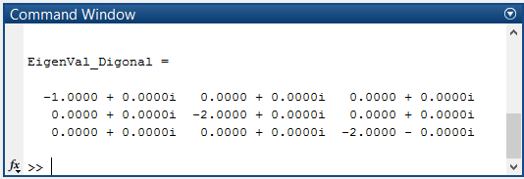

Matlab Result of corresponding transformation matrix which is matrix of Eigen vectors is given below.

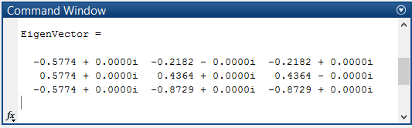

Eigen values computed by using state space matrix are same as poles of system, which are plotted in below graph.

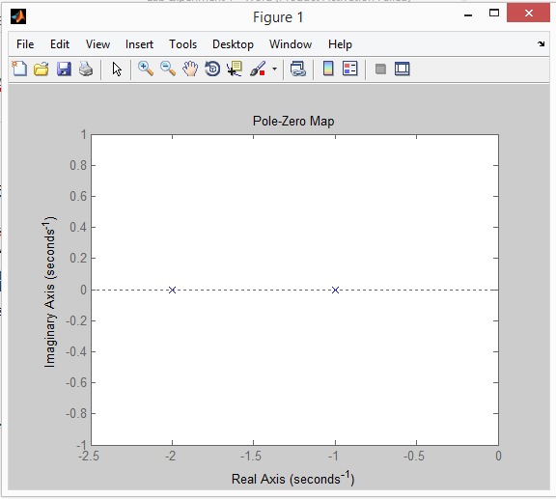

# Matlab Code

%Question No 4

close all;

clear all;

clc;

A = [0 1 0; 0 0 1; -4 -8 -5];

B=[0 0 1]';

C=[1 0 0];

D=0;

EigenVal = eig(A)

[EigenVector,EigenVal_Digonal]=eig(A)

figure;

sys = ss(A, B, C, D);

pzmap(sys)

# Question 05

Calculate e^At by using function expm(): find the value of eAt when t=0.3.



# Solution of Question 05

# Matlab Steps

We define the matrix A in matlab then we find e^At using matlab function expm(t*A), After that we find the value of eAt when t=0.3 using matlab function expm(0.3*A).

# Matlab Result

Matlab Result of e^At is given below.

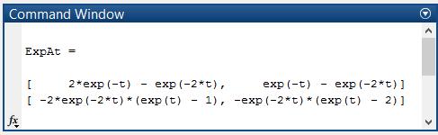

Matlab Result of eAt when t=0.3 is given below.

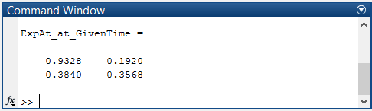

# Matlab Code

%Question No 4

close all;

clear all;

clc;

A=[0 1; -2 -3];

syms t;

ExpAt = simplify(expm(t*A))

ExpAt_at_GivenTime=expm(0.3*A)

# Question 06

Calculate the outputs of a system by using functions initial(), step() and lsim().  
Try to find the output of the following system between [0,10s] with a square wave  
input that has a period of 3s.



# Solution of Question 06

# Matlab Steps

1. From the given state space model we define the matrix A, B, C, D and initial condition x0, after that we define state space model **“sys = ss(A,B,C,D)”**.
2. We generate the square wave as a input signal with period of 3s and the duration is (0-10)s using matlab command **“u=square(2*pi*f*t)”.**
3. We find the initial response of state space model using “**initial(sys,x0)”** command.
4. We find the unit step response of state space model using “**step(sys)”** command.
5. We compute the output with square wave using **“lsim(sys,u,t,x0)”.**

# Matlab Result

Matlab Result of the initial response of state space model using “**initial(sys,x0)”** is given below.

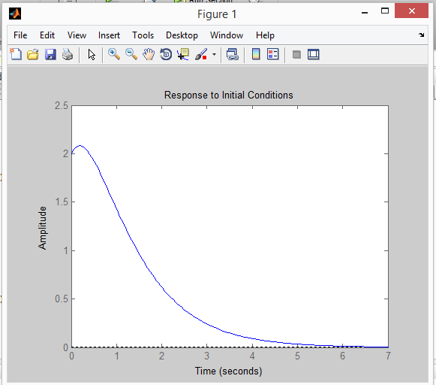

Matlab Result of the unit step response of state space model using “**step(sys)”**

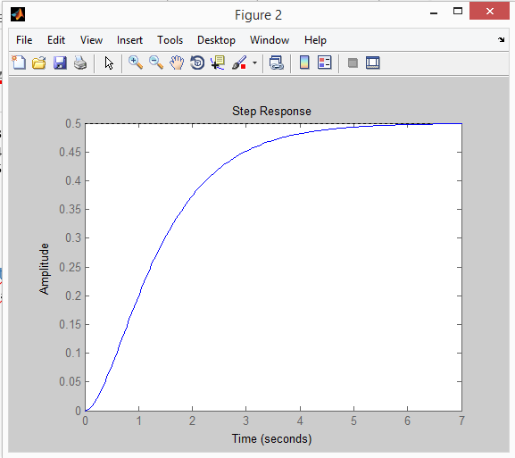

Matlab Result of the output with square wave using **“lsim(sys,u,t)”.**

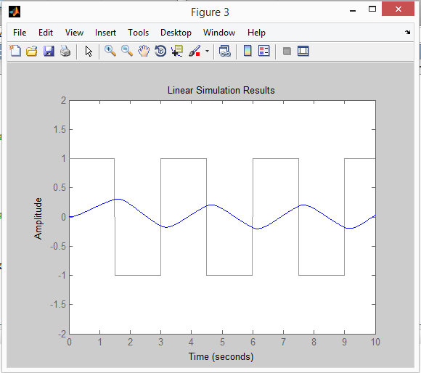

Matlab Result of the output with square wave using **“lsim(sys,u,t,x0)”.**

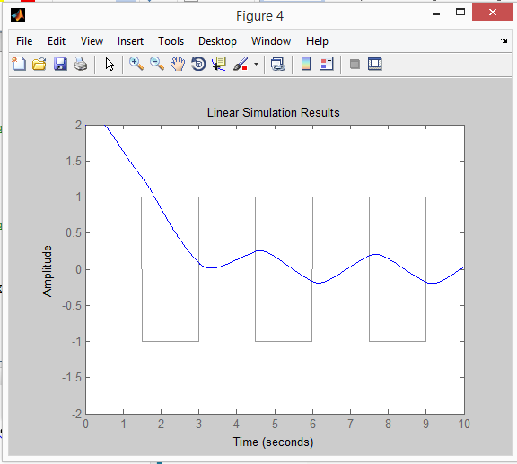

# Matlab Code

%Question No 6

close all; clear all; clc;

A=[0 1;-2 -3]; B=[0 1]'; C=[1 0]; D=0; X0=[2 1]';

t=0:0.01:10; f=1/3;

u=square(2*pi*f*t);

sys = ss(A,B,C,D)

% initial response of state space model using “initial(sys,x0)”

figure;

initial(sys,X0)

% the unit step response of state space model using “step(sys)”

figure;

step(sys)

% output with square wave using “lsim(sys,u,t)”.

figure;

plot(t,u);

hold on;

lsim(sys ,u ,t)

axis([0 10 -2 2])

% output with square wave using “lsim(sys,u,t,x0)”.

figure;

plot(t,u);

hold on;

lsim(sys ,u ,t,X0)

axis([0 10 -2 2])